Student Name: Amangeldi Madi

Group CS-2104

Total Points (20 pts) whatever

**Due: April 12, 2022 10:00AM**

**Homework assignment 1.**

Algorithms and Data Structures

Astana IT University

**Problem 1 (7 points):**

Problem Description:

An H-tree is a fractal defined as follows:

1. Begin with a letter H. The three lines of the H are of the same length, as shown in Figure a.

2. The letter H (in its sans-serif form, H) has four endpoints. Draw an H centered at each of the four endpoints to an H-tree of order 1, as shown in Figure b. These H’s are half the size of the H that contains the four endpoints.

3. Repeat step 2 to create a H-tree of order 2, 3, ..., and so on, as shown in Figure c-d.

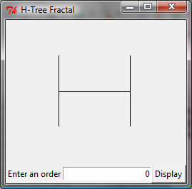 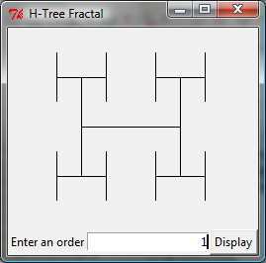 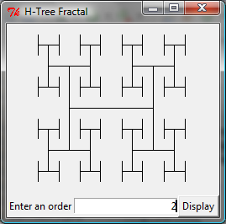 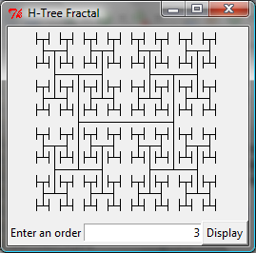

(a) (b) (c) (d)

The H-tree is used in VLSI design as a clock distribution network for routing timing signals to all parts of a chip with equal propagation delays. Write a JavaFX program that draws an H-tree, as shown in the figure.

Design:

Describe your recursive drawing method.

Three lines make H-shape, which is spreading by placing another four on each corner by reducing in size half as previous order.

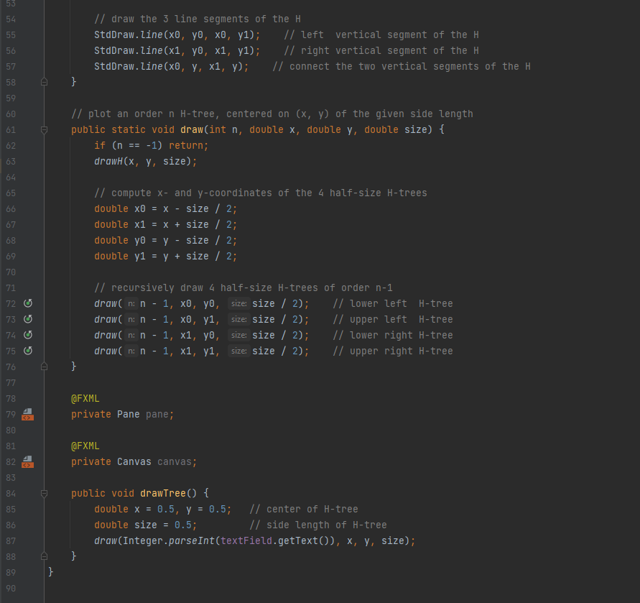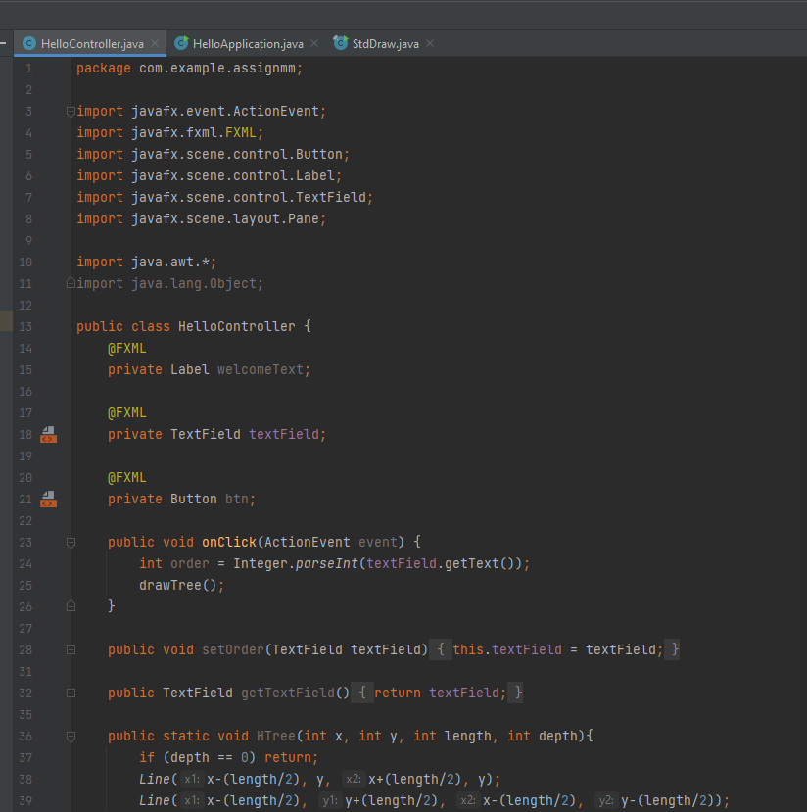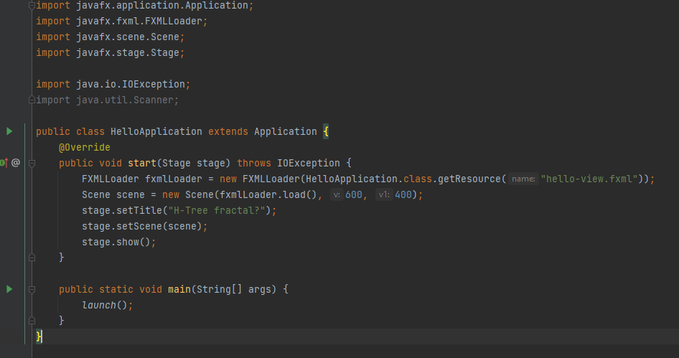Paste your source code here:

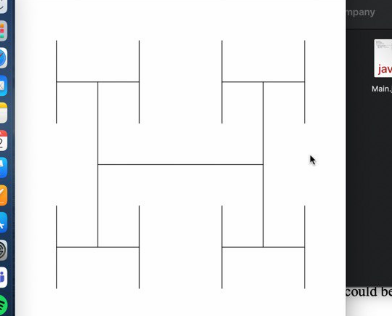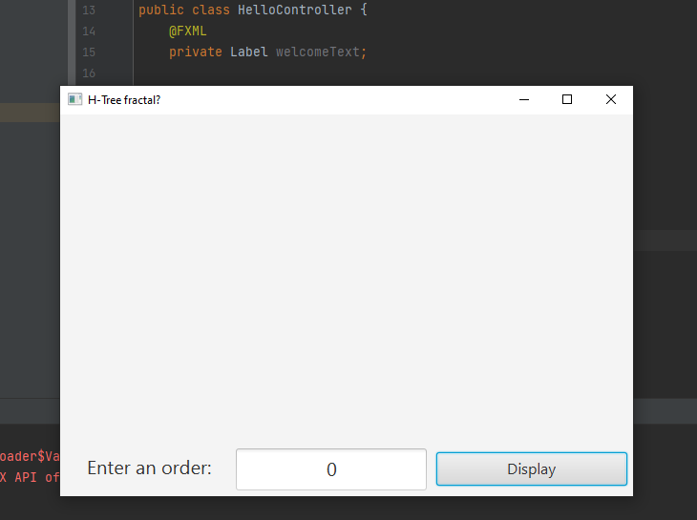Screen shot of two sample runs:

A screenshot of javaFX UI

Screens of my program from a friend’s MacBook

3. Fill in self-evaluation:

1. Can your program display a single H shape? ___yes_________
2. Can your program display H shapes recursively? ___yes_________
3. Can your shape size change as you resize the window? ___a little______
4. Can your shape fill in the entire window when the window is maximized? ___yes_________

**Problem 2 (7 points):**

Problem Description:

Write a program that prompts the user to enter a directory and displays the number of the files in the directory.

Analysis:

(Describe the problem including input and output in your own words.)

Should make a program with text field and button. Text field will be the input of directory. Code will print the number of files there.

Design:

(Describe the major steps for solving the problem. How do you use recursion to solve this problem.)

Get a directory from the UI and make a list from the inner files. Then print the size of the list.

Coding: (Copy and Paste Source Code here. Format your code using Courier 10pts)

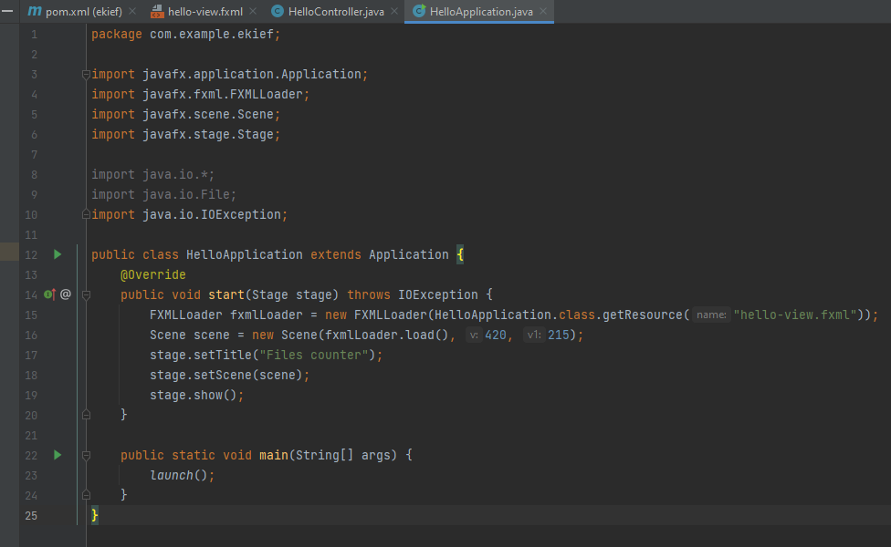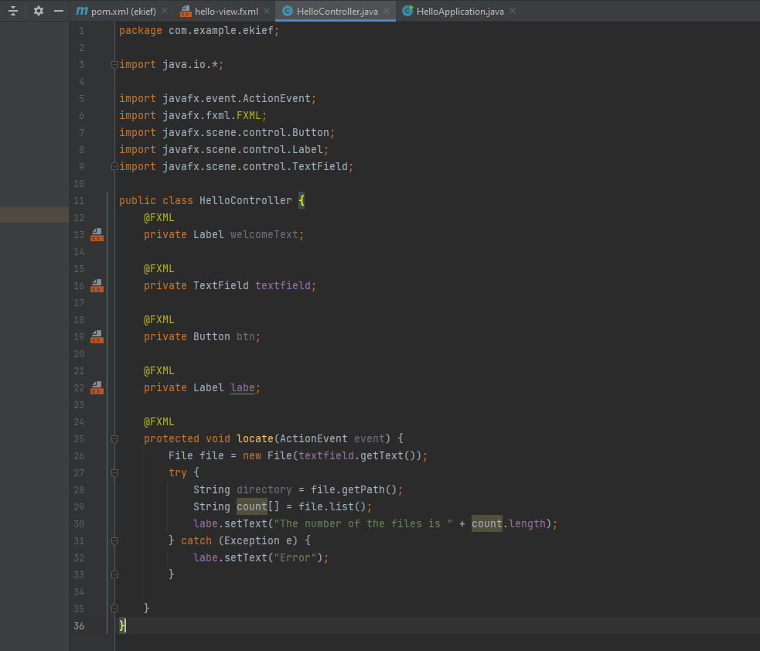

Testing: (Describe how you test this program, screen shot of two sample runs:)

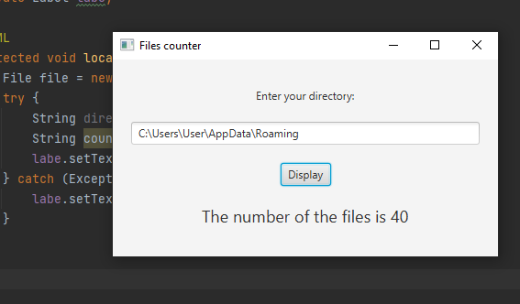

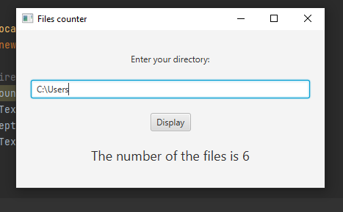

**Problem 3 (6 points):**

Problem Description:

Write a program that reads a Java source-code file and reports the number of keywords (including null, true, and false) in the file. If a keyword is in a comment or in a string, don’t count it. Pass the Java file name from the command line. (Hint: Create a set to store all the Java keywords.)

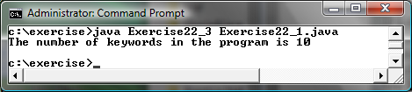

Analysis:

(Describe the problem including input and output in your own words.)

You give the java source code as an argument to your program so that it counts a number of java keywords.

Design:

(Describe the major steps for solving the problem.)

Go through the code and store words in a list. Then get a size of that list

Coding: (Copy and Paste Source Code here. Format your code using Courier 10pts)

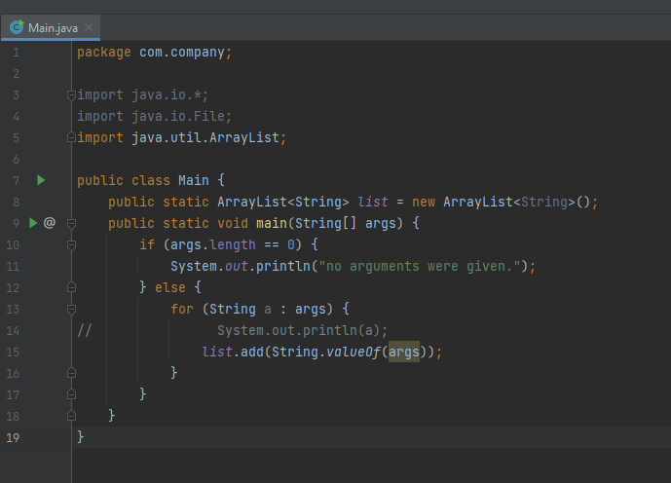

2. Fill in self-evaluation:

1. Can your program pass file name from the command-line? _______________
2. Can your program read text contents from the file? _______________
3. Can your program read a line from the file? _______________
4. Can your program strip out line comments from a line? _______________
5. Can your program strip out string literals from a line? _______________
6. Can your program strip out paragraph comments? _______________
7. Can your program decide whether a word is a keyword? _______________
8. Can your program count keywords? _______________

3. Test your program to count the keywords in the following file (Describe how you test this program, screen shot of two sample runs)

// This application displays Welcome to Java!

public class Welcome {

public Welcome() {

super();

}

public static void main(String[] args) {

System.out.println("Welcome to int int int Java!");

// int

/* this(); int

*/

}

}

**Submit the following items as one ZIP file which contains:**

1. This word file should be converted and submitted as PDF file.

2. Your JAVA file